1. Let’s inspect the running cluster.
2. To do that let’s open the **console tool in Kibana**.
3. 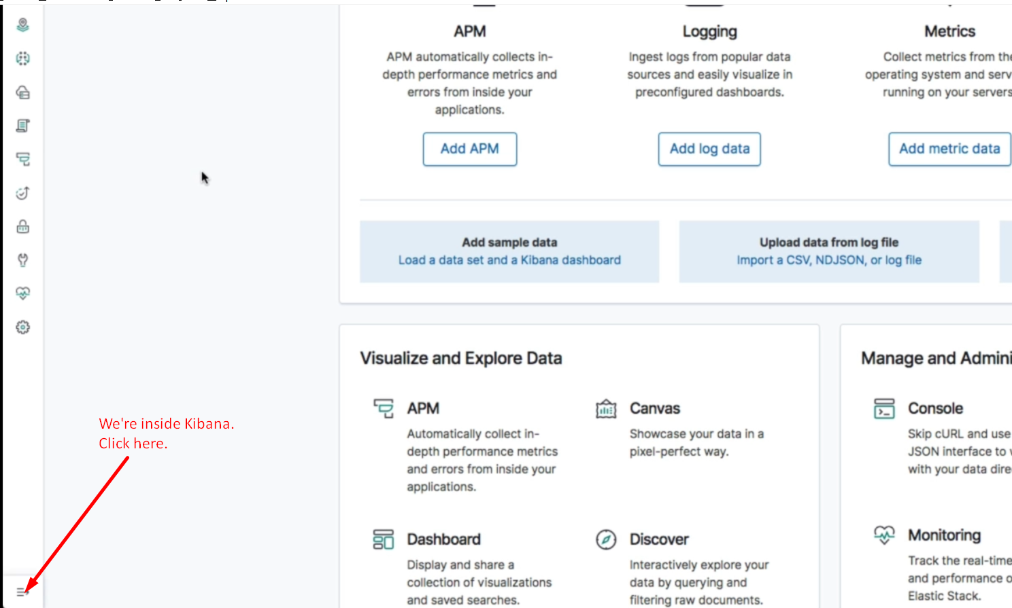  
   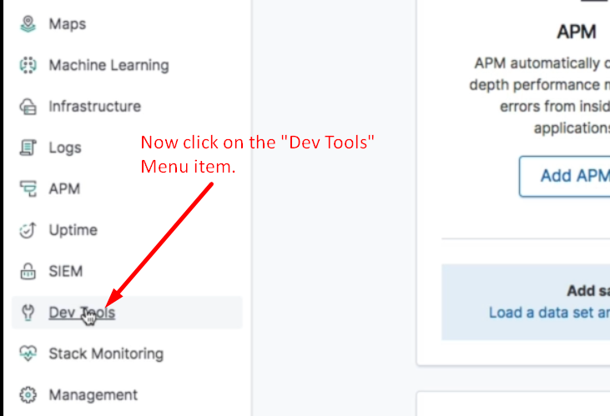
4. This would be the first time; we would be sending request to Elasticsearch through Kibana. Earlier, we had sent by CMD using curl command and powershell using command invoke-restmethod.
5. Elasticsearch Cluster exposes **API** which is what we will be communicating with using Kibana Console Too.  
   Although, we will be typing our query in Kibana’s Console Tool but under the hood, it would be calling REST API.  
   We can use any other HTTP Clients🡺 cURL in CMD, POSTMAN etc.
6. The format in which we need to enter queries within console is to start by specifying the HTTP verb.
7. Let’s begin by retrieving the info about **Cluster Health**.

HTTP_VERB address/request_path but address is not required as specified in **Kibana’s configuration in some file**.

1. 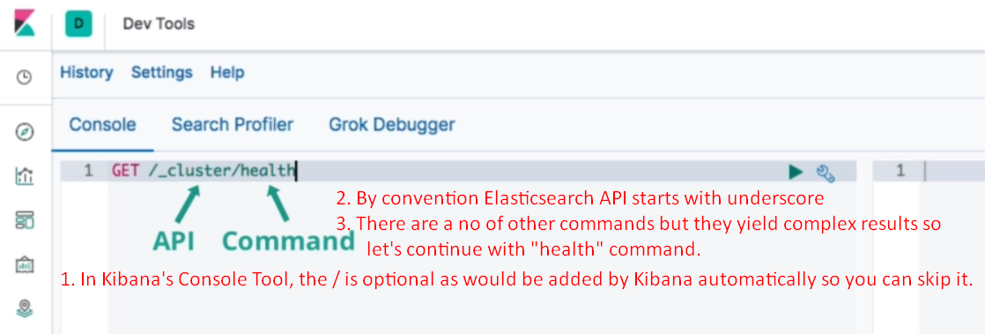  
   **NOTE**: There are other commands which can be used to retrieve info about nodes and clusters. These commands yield results that are too complex to get into right now. So let’s stick to the “health” command and run the **query**.
2. Result for the query which is JSON object containing info about the cluster.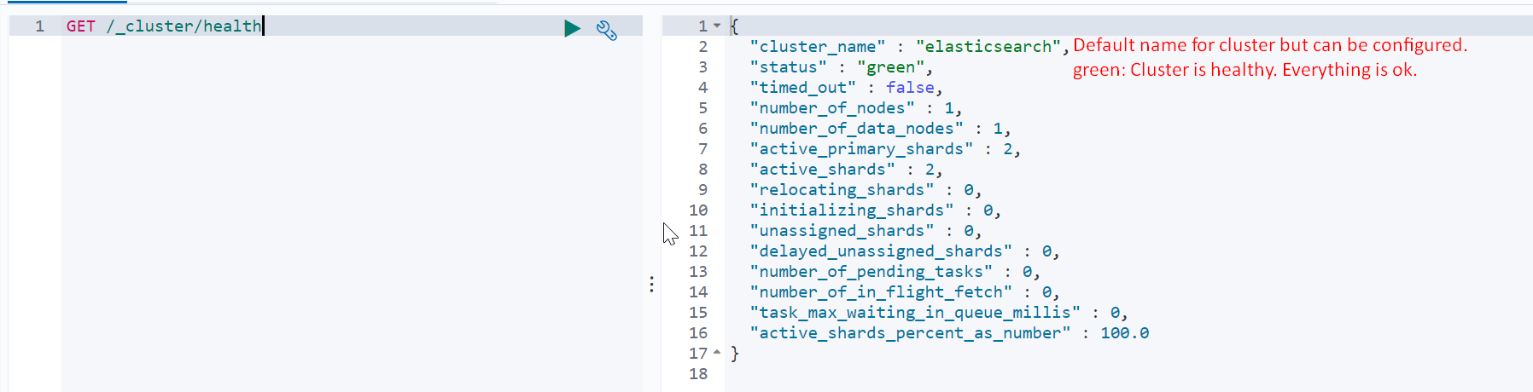
3. **Node Info**: Let’s continue exploring the cluster; this time listing the nodes inside the cluster.  
   For that we have _cat API which gives result in human readable form.  
   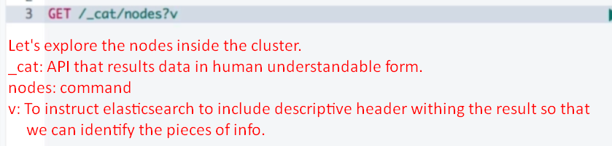
4. 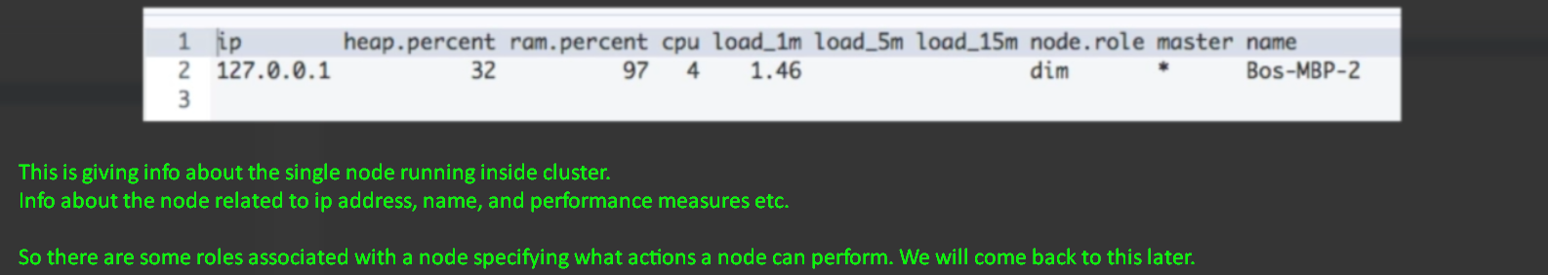
5. There is an API _nodes which returns detailed data in JSON format that maybe useful in debugging.
6. 
7. Let’s check which indices our cluster has using the “indices” command for “_cat” API.
8. 
9. You can see two indices by default. As you know, Kibana is just a web interface for Elasticsearch. If you set up a dashboard or configure machine learning jobs, this configuration needs to be persisted somewhere. Kibana doesn’t ship with a database of any kind, so where does it store this data?
10. This means that if you set up a fresh instance of Kibana and point it to an existing Elasticsearch cluster, all of the existing Kibana data will be loaded.   
    That’s much more convenient than having to manage some other kind of data store.
11. The leading dot is used to hide indices within the Kibana interface.  
    